**NAME: DHANRAJ SUBHASH KORE**

**DIV: TY B** **BATCH: B3**

**ROLL NO: 60**

**SUB: CNT LAB ASSIGNMENT**

**Submission of Code Section and Preview Result Section for Basics of HTML of 10 Assignments in single pdf for IIT Delhi Virtual Lab.**

**Assignment-1**

**Code:**

<!DOCTYPE html>

<html lang="en" dir="ltr">

<body>

<h1>This is heading 1 </h1>

<h2>This is heading 2 </h2>

<h3>This is heading 3 </h3>

<h4>This is heading 4 </h4>

<h5>This is heading 5 </h5>

<h6>This is heading 6 </h6>

<p>Hello World</p>

<b>Hello</b>

<i>hello</i>

<u>Hello</u>

<big>Hello</big>

<small>Hello</small>

</body>

</html>

**O/P:**

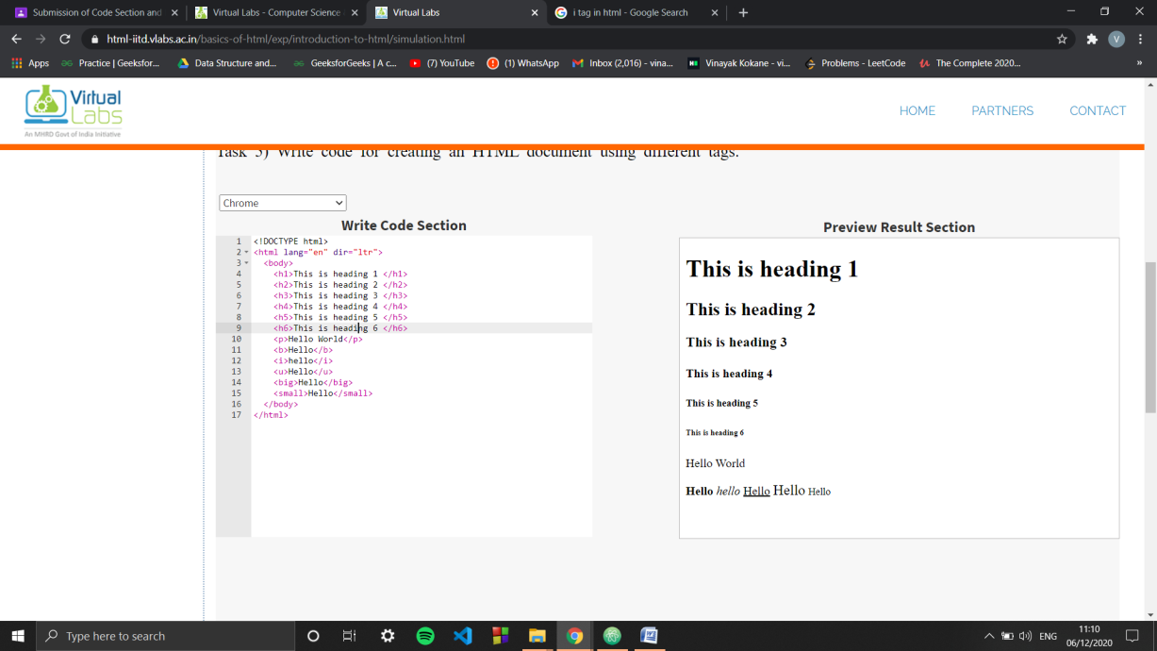

**Assignment-2**

**Code:**

<!DOCTYPE html>

<html>

<body bgcolor = "#ffff33" background = "" text = "#ff00ff">

<font face = "Impact">The quick brown fox jumps over a lazy dog</p>

<p align="left">Left Align</p>

<p align="right">Right Align</p>

<p align="center">Center Align</p>

<h1 align="left">Hello World</h1>

<h1 align="right">Hello World</h1>

<h1 align="center">Hello World</h1>

</body>

</html>

**O/P:**

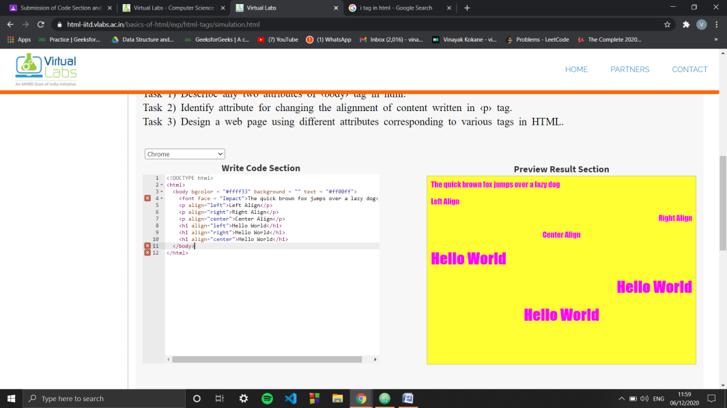

**Assignment-3**

**Code:**

<!DOCTYPE html>

<html>

<body>

<img src="https://html-iitd.vlabs.ac.in/basics-of-html/exp/img-tags-in-html/assets/images/logo-new.png" alt="virtual-lab" />

<img border="3px" height="200px" width="500px" src="https://images.firstpost.com/wp-content/uploads/2019/08/Chandrayaan-2-composite-orbiting-the-moon-before-the-landers-separation_ISRO.jpg" alt="" />

<img border="3px" height="200px" width="500px" src="https://images.indianexpress.com/2019/07/chandrayaan-2_1200-1.jpg" alt="" />

</body>

</html>

**O/P:**

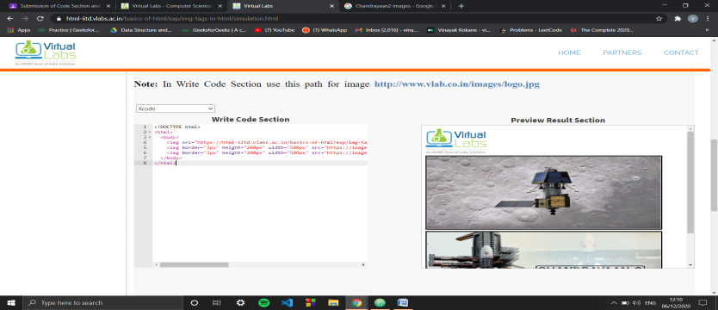

**Assignment-4**

**Code:**

<!DOCTYPE html>

<html>

<body>

<a href="https://html-iitd.vlabs.ac.in/">Visit Virtual Babs by MHRD here</a> <br />

<a href="http://vlabs.iitkgp.ernet.in/scte/">Visit here for KGPs Soft Computing Tools in Engineering Lab</a> <br />

<a href="http://ps-iiith.vlabs.ac.in/">Problem Solving by IIT Hyd</a>

</body>

</html>

**O/P:**

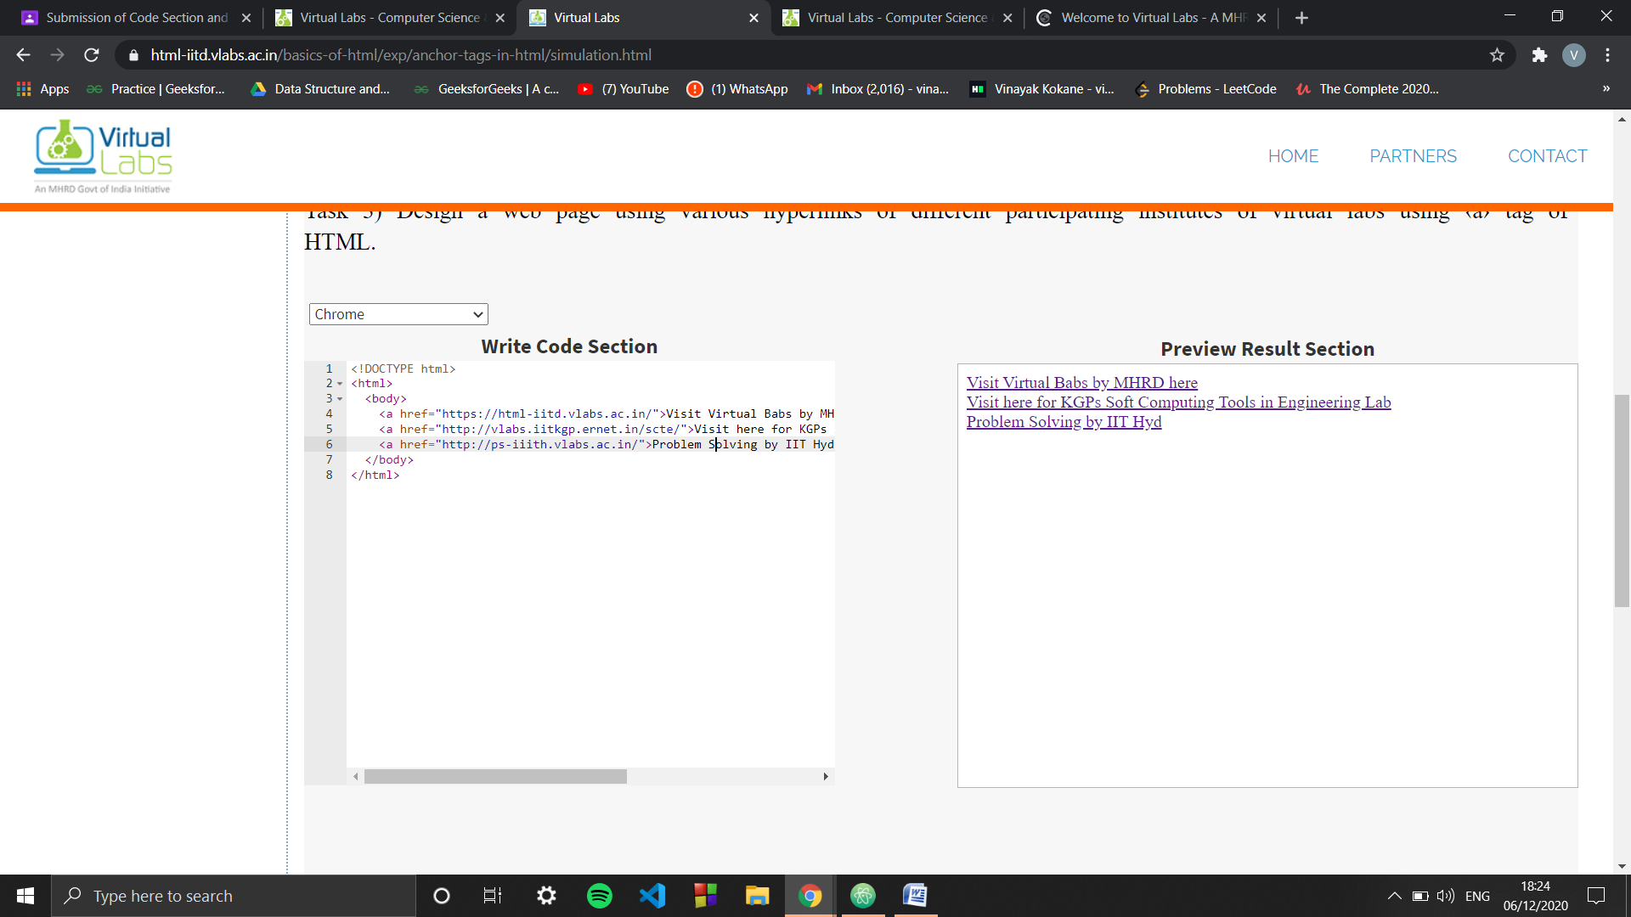

**Assignment-5**

**Code:**

<!DOCTYPE html>

<body>

<marquee bgcolor="#80FF00">News from center</marquee>

<marquee direction="right" bgcolor="#CC000">News from center</marquee>

<marquee direction="up" height="100px" bgcolor="#FF9933">Welcome to IIT Delhi's Virtual lab</marquee>

</body>

</html>

**O/P:**

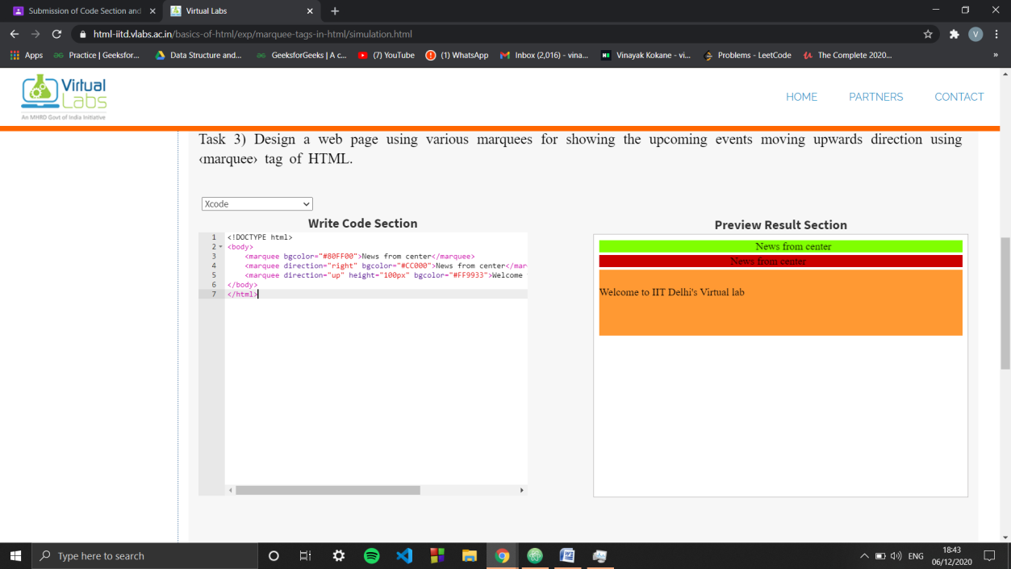

**Assignment-6**

**Code:**

<!Doctype html>

<body>

<table align="center" border="2px solid black">

<tr>

<td>Sachin</td>

<td>148*</td>

<td>180</td>

</tr>

<tr>

<td>Rohit</td>

<td>264</td>

<td>180</td>

</tr>

<tr>

<td>Dhoni</td>

<td>183*</td>

<td>200</td>

</tr>

<tr>

<td>Virat</td>

<td>183</td>

<td>150</td>

</tr>

<tr>

<td>Sehwag</td>

<td>219</td>

<td>189</td>

</tr>

</table>

<br>

<table align="center" bgcolor="#feffc0" border="2px solid black">

<tr>

<th>Name</th>

<th>Hours</th>

</tr>

<tr>

<td>Vinayak</td>

<td>10</td>

</tr>

<tr>

<td>Vedant</td>

<td>11</td>

</tr>

<tr>

<td>Suyash</td>

<td>12</td>

</tr>

<tr>

<td>Karan</td>

<td>10</td>

</tr>

<tr>

<td>Vilas</td>

<td>11</td>

</tr>

</table>

</body>

</html>

**O/P:**

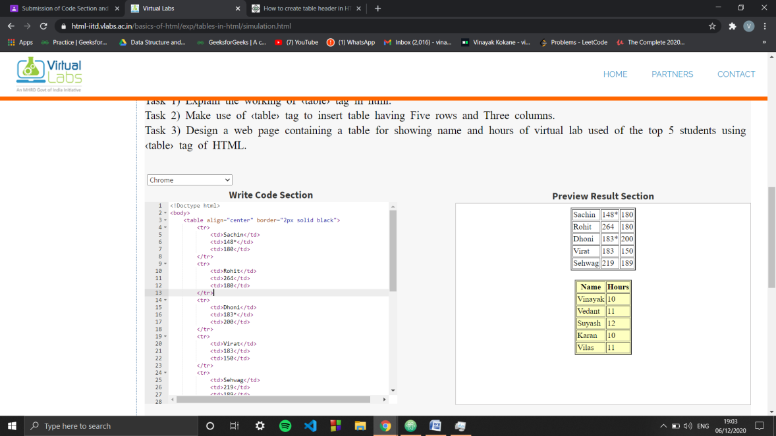

**Assignment-7**

**Code:**

<!DOCTYPE html>

<body>

<ul>

<li>Computer Science</li>

</ul>

<ol>

<li>Basics of html </li>

<li>Data Sturcutures (IIT Hyd)</li>

<li>ANN (IIT Hyd)</li>

<li>Pattere Recogbitions (IIT Hyd)</li>

<li>Softeare Engg (IIT Kharagpur)</li>

</ol>

<ul>

<li>IIT Delhi</li>

<li>IIT Hyd</li>

<li>IIT Kharagpur</li>

<li>AMRITA VISHWA VIDYAPEETHAM</li>

</ul>

</body>

</html>

**O/P:**

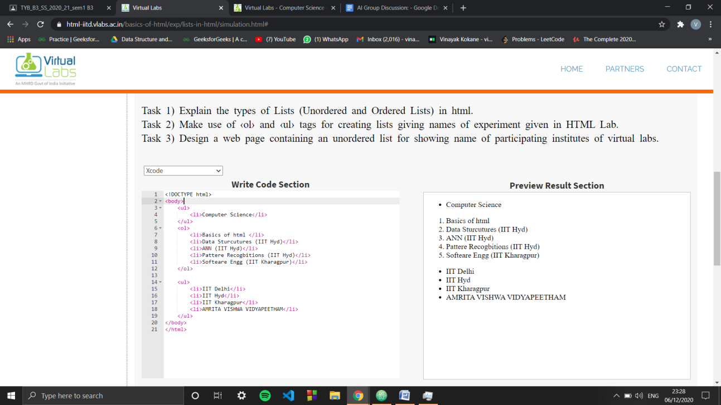

**Assignment-8**

**Code:**

<!DOCTYPE html>

<body>

<div style="width: 200px; height:100px; background-color:red;">div1

</div>

<div style="width: 200px; height:100px; background-color:blue;">div2

</div>

<div style="width: 200px; height:100px; background-color:green;">div3

</div> <br>

<div style="border:4px solid black; width: 200px; height:100px; background-color:#fff000;">New div

</div>

<div style="float:right; width: 200px; height:100px; background-color:#fff000;">New div

</div>

</body>

</html>

**O/P:**

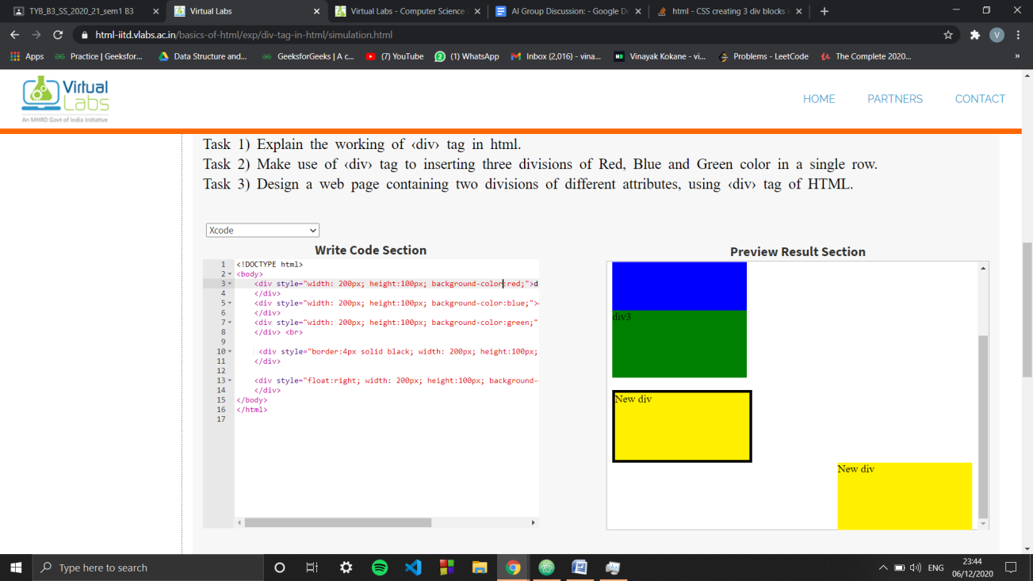

**Assignment-9**

**Code:**

<!DOCTYPE html>

<body>

<iframe src="https://www.google.com"></iframe>

<iframe width="100%" height="200px" src="https://www.vlab.co.in/broad-area-computer-science-and-engineering"> </iframe>

</body>

</html>

**O/P:**

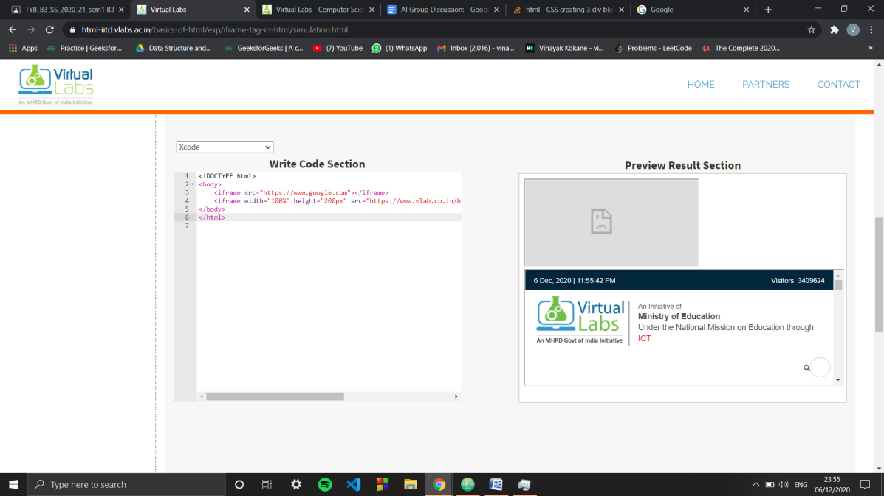

**Assignment-10**

**Code:**

‹table border='3px solid black' style="width:500px;height:500px;"›

‹tr›

‹td›Main Table‹/td›

‹/tr›

‹tr›

‹td›‹/td›

‹/tr›

‹tr›

‹td›‹/td›

‹/tr›

‹tr›

‹td›‹/td›

‹/tr›

‹tr›

‹td›‹/td›

‹/tr›

‹/table›